# Mobile App Development Lab

# Week 9

Program

Working with SQLite Database_insert and view operations

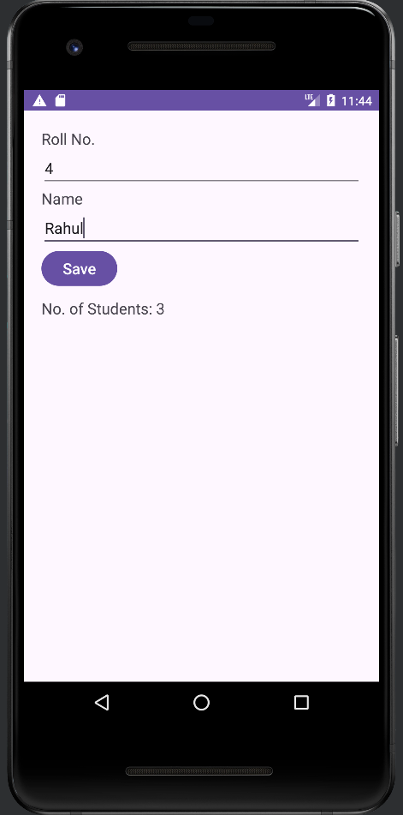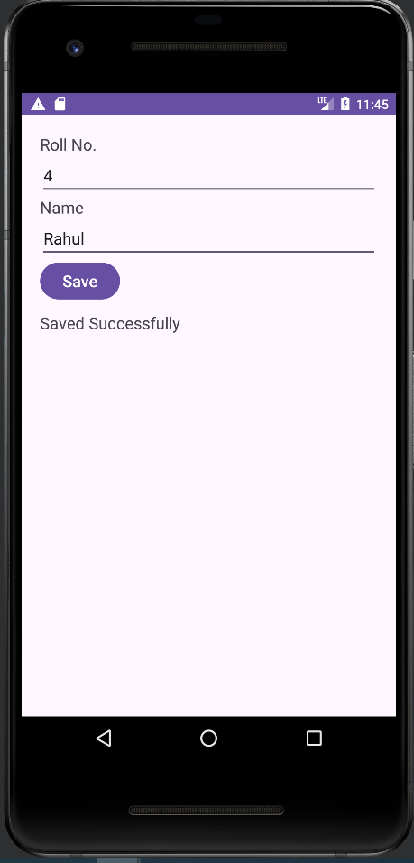

PROCEDURE:

Step 1: Create New Project

Step 2: Design activity_main.xml

Step 3: Create DbHandler.java and write the Code

Step 4: Add Write Java Code to Save Student Details in MainActivity.java file

Step 5: Run the App

Step 6: Check Database using Device File Explorer (/data/data/package/databases/) and Download to PC. Device File Explorer is available in view->Tool Windows

Step 7: Open Database in DB Browser (SQLite) and verify data (Download DB Browser Software from **(https://sqlitebrowser.org/dl/)**

# activity_main.xml

*<?*xml version="1.0" encoding="utf-8"*?>*

<androidx.appcompat.widget.LinearLayoutCompat xmlns:android="<http://schemas.android.com/apk/res/android>" xmlns:app="<http://schemas.android.com/apk/res-auto>"

xmlns:tools="<http://schemas.android.com/tools>" android:layout_width="match_parent" android:layout_height="match_parent" android:layout_margin="20dp" android:orientation="vertical" tools:context=".MainActivity">

<TextView android:id="@+id/txtRollNo" android:layout_width="match_parent" android:layout_height="wrap_content" android:textSize="18dp" android:text="Roll No." />

<EditText android:id="@+id/editTextRollNo" android:textSize="18dp" android:layout_width="match_parent" android:layout_height="wrap_content"/>

<TextView android:id="@+id/txtName" android:textSize="18dp"

android:layout_width="match_parent" android:layout_height="wrap_content " android:text="Name" />

<EditText android:id="@+id/editTextName" android:textSize="18dp" android:layout_width="match_parent"

android:layout_height="wrap_content" />

<Button

android:id="@+id/btnSave" android:textSize="18dp" android:layout_width="wrap_content" android:layout_height="wrap_content" android:text="Save" />

<TextView android:id="@+id/textMessage" android:textSize="18dp" android:layout_marginTop="10dp" android:layout_width="match_parent" android:layout_height="wrap_content" android:text="No. of Students:" />

</androidx.appcompat.widget.LinearLayoutCompat>

# DbHandler.java

**package** com.example.sqlitedemo;

**import** android.content.ContentValues; **import** android.content.Context; **import** android.database.Cursor;

### **import** android.database.sqlite.SQLiteDatabase;

**import** android.database.sqlite.SQLiteOpenHelper;

**public class** DbHandler **extends** SQLiteOpenHelper {

**private static final int *DB_VERSION*** = 1;

**private static final** String ***DB_NAME*** = **"mru.db"**;

**public** DbHandler(Context context){

**super**(context, ***DB_NAME***, **null**, ***DB_VERSION***);

}

### @Override

**public void** onCreate(SQLiteDatabase db){

String CREATE_TABLE = **"CREATE TABLE Student (RollNo TEXT PRIMARY KEY, NAME TEXT)"**;

### db.execSQL(CREATE_TABLE);

}

### @Override

**public void** onUpgrade(SQLiteDatabase db, **int** oldVersion, **int** newVersion){

}

*// Adding new Student Details*

### **boolean** SaveStudentDetails(String rollNo, String name){ SQLiteDatabase db = **this**.getWritableDatabase();

*//Create a new map of values, where column names are the keys*

### ContentValues cValues = **new** ContentValues();

cValues.put(**"RollNo"**, rollNo);

cValues.put(**"Name"**, name);

*// Insert the new row*

Long returnValue = db.insert(**"Student"**,**null**, cValues);

db.close();

**if** (returnValue>0){

## return true;

}**else** {

## return false;

}

}

*// Get Student List*

**public** Cursor GetStudentList() {

### SQLiteDatabase db = **this**.getReadableDatabase();

Cursor res = db.rawQuery( **"select * from Student"**, **null** );

**return** res;

}

}

# MainActivity.java

**package** com.example.sqlitedemo;

### **import** androidx.appcompat.app.AppCompatActivity;

**import** android.database.Cursor; **import** android.os.Bundle; **import** android.view.View; **import** android.widget.Button; **import** android.widget.EditText; **import** android.widget.TextView;

**public class** MainActivity **extends** AppCompatActivity {

EditText **editTextRollNo**, **editTextName**;

Button **btnSave**;

TextView **textMessage**;

DbHandler **dbHandler**;

### @Override

**protected void** onCreate(Bundle savedInstanceState) { **super**.onCreate(savedInstanceState); setContentView(R.layout.***activity_main***);

**dbHandler** = **new** DbHandler(MainActivity.**this**);

*// Get Student List from SQLite Database*

Cursor cursor = **dbHandler**.GetStudentList();

**textMessage** = (TextView)findViewById(R.id.***textMessage***);

**textMessage**.setText(**"No. of Students: "** + cursor.getCount());

**btnSave** = (Button)findViewById(R.id.***btnSave***);

### **btnSave**.setOnClickListener(**new** View.OnClickListener() { @Override

**public void** onClick(View v) {

**editTextRollNo** = (EditText)findViewById(R.id.***editTextRollNo***);

**editTextName** = (EditText)findViewById(R.id.***editTextName***); String rollNo = **editTextRollNo**.getText().toString();String name = **editTextName**.getText().toString();

### Boolean returnValue = **dbHandler**.SaveStudentDetails(rollNo, name)

**if** (returnValue == **true**){

**textMessage**.setText(**"Saved Successfully"**);

}**else**{

**textMessage**.setText(**"Record Already Exists"**);

}

}

});

}

}